**15C – Relativistic Velocity Transformation**

**Topics:** Special relativity, Lorentz transformations, relativistic addition of velocities.

**Summary:** Students derive the velocity addition formula using the Lorentz transformations and the definition for the velocity in two different inertial frames.

**Written by:** Michael Dubson, Charles Baily and Steven Pollock.

**Contact:** Steven.Pollock@Colorado.EDU

**Comments:** Students should be able to complete these tasks in less than 10 minutes. The tasks are fairly straightforward, and the biggest difficulty for students may be the algebra. A common problem is for students to be confused about the velocity of the frame *v*, and the velocity of the particle *u* in that frame of reference. We have also noticed some conceptual difficulty for students regarding an event taking place at a single point in spacetime, and the different coordinate representations of that point in different inertial frames. The Lorentz transformations are written in a form that makes the symmetry between the two equations more obvious.



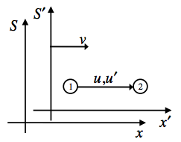



Frame  moves with a constant velocity  relative to frame . An object moves from Event 1 to Event 2 with constant speed along the  direction.

In frame , its velocity is .

In frame , its velocity is .

Rewrite  in terms of the unprimed variables  and  using the Lorentz transformations at the top of the page.

Simplify this result to find a relationship between  and . Notice that this is not a simple Lorentz transformation. Why not?